**Tip Calculator Programming Assignment**

For this assignment you are going to program a JavaFX tip calculator app like you might find on your phone. The interface is shown below.

To use the app the user types in the check amount. The user then chooses a tip percent using a slider. The user can elect to split the total by up to 5 people by selecting from the *Split* choice box. Press the calculate tip button to calculate the tip. Your application should display the tip amount, the total bill, and the amount per person.

Use a grid layout pane for your application. The title and calculate tip button should span 2 columns. Note that all text is right-justified. You should choose a font other than the default font for the application. The title should be in a second, larger font. The tip percent label should reflect the value of the slider. All output values should be formatted as currency. The user should not be allowed to edit or change the tip amount, the total and the amount per person. The default value for the tip percent should be set at 20%. The default value of the *Split* choice box should be set to “1 way”.

Sample run:

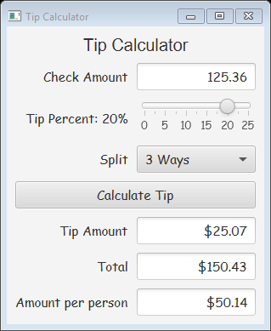

When the user clicks in the check amount text field your program should reset the application to its default state so that the user can enter a new check amount. To do this, all text fields should be cleared, the tip percent should be set to 20% and the split choice box should be set to read “1 Way”.